Isolation and Structure Determination of Antioxidants Active Compounds from Ethyl Acetate Extract of Heartwood Namnam (Cynometra cauliflora L.)

Dede Sukandar^{1*}, Siti Nurbayti¹, Tarso Rudiana¹, and Tsalats Wahyul Husna¹
1Department of Chemistry Faculty of Science and Technology Syarif Hidayatullah State Islamic University Jakarta,
Jl. Ir. H. Juanda No. 95 Ciputat 15412 Indonesia, Phone (021) 7401925
*Corresponding author: sukandarkimia@uinjkt.ac.id

A R T I C L E I N F O
Article history:
Received date :15 January 2017

Revised date : 25 April 2017 Accepted date:10 May 2017
Available online at : http://inajac.lipi.go.id

Keywords:
Antioxidant, apigenin, DPPH, namnam (Cynometra cauliflora L.), phenolic.
Abstract
Active compounds with antioxidant activity were isolated from ethyl acetate extract of namnam stem (C. cauliflora L.) that had undergone maceration and fractionation by gravity column chromatography. The compounds were later identified by by using UV-Vis Spectrophotometry, FTIR, LCMS and 1H-NMR. Ethyl acetate extract of namnam stem showed considerably high antioxidant activity (IC₅₀ value 4.68 ± 0.035 ppm). The results of analysis by UV-Vis and FTIR showed carbonyl group conjugated with an aromatic ring at band I (λ_{max} 330.22 nm), chromophore group of alkene (C=C) at band II (λ_{max} 268.67 nm) and functional groups such as O−H (3343.91 cm⁻¹), C=O (1729.23 cm⁻¹), C=C (1652.64 and 1611.99 cm⁻¹), C−O (1269.89) and C−H
ortho (738.23 cm⁻¹). LCMS (m/z 270.9246) and ¹H-NMR data showed seven proton signals on the aromatic ring at carbon position C-3 at δ_{H} 6.86 ppm (1H, s), C-6 at δ_{H} 5.95 ppm (1H, d, J=1.95 Hz), C-8 at δ_{H} 6.25 ppm (1H, d, J= 1.95 Hz), C-2’ and C-6’ at δ_{H} 7.03 ppm (2H, d, J=7.87 Hz), C-3’ and C-5’
at δ_{H} 6.87 ppm (2H, d, J= 7.87 Hz) so that the structure was identified as a flavonoid which was 4 ', 5,7-trihydroxy-flavones or known as apigenin. The isolated apigenin had very strong antioxidant activity, as shown by IC₅₀ value of 5.18 ± 0.014 ppm.
© 2017 Indonesian Journal of Applied Chemistry. All rights reserved

INTRODUCTION
Lifestyle, especially in big cities, is characterized by everything that is practical and fast paced. Although it is not entirely deleterious, practical and efficient lifestyles need to be reconsidered, especially with regards to the diet. Nowadays, people tend to consume a diet high in calorie, fat and sugar, but low in fiber and antioxidants, which can lead to degenerative diseases, such as coronary heart disease, stroke and hypertension. Therefore, adequate intake of antioxidants is necessary for all age groups [1].
Continuous consumption of antioxidants in a sufficient amount is aimed to inhibit and decrease the risk of degenerative diseases [2]. A plant may have antioxidant activity when it contains compounds like phenols and flavonoids that can counteract free radicals [3]. Namnam is a plant from the family of legumes
(Fabaceae), with the scientific name of Cynometra cauliflora. It was reported that the plants in the family produced phenolic compounds rich in hydroxyl groups, especially oligostilbenoid groups [4]. Oligostilbenoids have been reported to exhibit some biological activity, for instance as antioxidant [5], anti- HIV [6], antibacterial [7] and cytotoxic agents [6].
Phytochemical tests proved that wood, bark, and young and old leaves of namnam contain tannins, saponins and flavonoids [8]. Results of previous studies showed that namnam fruit contains active compounds flavonoids, triterpenoid, saponins and tannins that are efficacious as an antioxidant with IC₅₀ value of 328.29 ppm [9]. Based on a study mentioning that water extract of namnam fruit had antioxidant activity assessed by FRAP method with IC₅₀ value of 403.04 ppm [10]. It

was also reported that the methanol extract of the namnam fruit was cytotoxic to HL-60 leukemia cells, inducing apoptosis and inhibits cell proliferation [11].

MATERIAL AND METHOD
  - Plants Material
Samples of namnam heartwood (C. cauliflora) was obtained from the Cintaratu Village-Parigi District of Pangandaran, West Java and confirmed by Bogoriense Herbarium- Indonesian Institute of Science.

Extraction and Fractionation
500 g of powder C. cauliflora was macerated with methanol and fractionated using n-hexane and ethyl acetate. The sampless were then evaporated to obtain dry extracts.

Antioxidant Activity Essay Using DPPH Method
Antioxidant test was performed using DPPH free radical scavenging method. Samples were dissolved in methanol (concentrations were varied to 0.15; 0.3; 0.6;
1.2; 2.4; 4.8; 9.6 ppm), reacted with 0.002% DPPH, incubated for 30 min at room temperature, and then measured for their absorbance at the maximum wavelength of DPPH. The antioxidant activity was calculated as an inhibition percentage of DPPH or scavenging effect.
% inhibition = [(blank absorbance – sample absorbance sample) / blank absorbance ] x 100%. IC₅₀ was the concentration of the sample required to give a 50% inhibition.

Column Chromatography Gravity
6 grams of ethyl acetate extract was fractionated using gravity column chromatography with 100% n-hexane,n- hexane-ethyl acetate (1%, 2%, 3%, 4%, 5%, 8%, and 10% n-hexane in ethyl acetate) and 100% methanol as eluents. The fraction was analyzed by thin layer chromatography and sprayed with DPPH to determine antioxidant activity. Active fractions were further
separated using gravity column chromatography to obtain a purer and more active components.

Analysis Using UV-Vis, FTIR, GC-MS and 1H NMR.
Purer fraction was analyzed using a UV- Vis, FTIR, GC-MS and ¹H NMR to determine the compounds found in the isolates.

RESULTS AND DISCUSSION
This study was conducted to isolate antioxidants from the ethyl acetate extract of heartwood namnam.
The antioxidant data showed that the ethyl acetate extract of heartwood namnam was more active than the methanol extract, so that the ethyl acetate extract was further separated to obtain pure compounds.

Table 1. Antioxidant activity of methanol extract from namnam heartwood

Sample | IC₅₀ (ppm)
Quercetin | 1.52 0.007
MeOH extract (Crude) | 6.25 0.084
n-hexane extract | 53.36 1.88
EtOAc extract | 4.68 0.035
MeOH-H₂O residue | 6.25 0.03

The ethyl acetate extract with IC₅₀ value of
  - ± 0.035 ppm could be categorized as a very powerful antioxidant. Antioxidant activity is classified as “very powerful” if the IC₅₀ value is less than 50 ppm, “strong” if the IC₅₀ value is 50-100 ppm, if the IC₅₀ is 101- 150 ppm, and “weak” if the IC₅₀ is 150-200 ppm [12].
The positive control used was quercetin. Quercetin is a flavonol group of compounds largest and glicoside present in an amount of about 60-75% of the flavonoids [13]. Quercetin is also indicated as a flavonoid with powerful antioxidant capacity. Our analysis showed that IC₅₀ value of quercetin was 1.52 ppm.

Three functional groups of quercetin which help in maintaining the stability and act as antioxidants when they react with free radicals are O-dihydroxyl in ring B, 4-oxo group in conjugation with the alkene 2,3 and 3- and 5- hydroxyl groups [14]. The functional groups can donate electrons to the ring that would increase the amount of resonance in benzene structure of quercetin [15].
The TLC analysis using Si-gel Kiesel gel 60 F₂₅₄ plate (Merck) as the stationary phase and n-hexane:ethyl acetate (1:1) as the mobile phase on ethyl acetate extract of namnam heartwood (Figure 1) resulted in 5 stainings with Rf values of 0.3; 0.42; 0.5; 0.57 and 0.7.

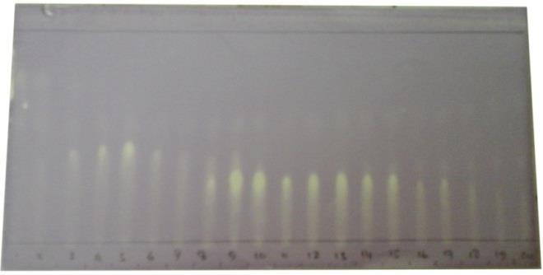

F1 F2 F3

Fig. 2. TLC antioxidant autobiography ofeach fraction
Column chromatography fractionation results were also tested for their antioxidant activity using DPPH method to determine which fraction that had the highest antioxidant activity. The test results of antioxidant activity of each fraction are presented in Table 2.

Table 2. Antioxidant activity isolates results chromatography columns
Sample | IC₅₀ (ppm)
F1 | 10.11 0.11
F2 | 5.18 0.014
F3 | 12.83 0.27

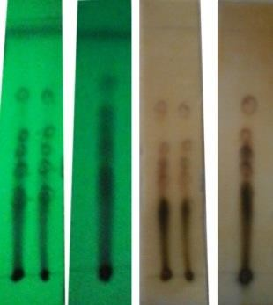
(b)
Fig. 1. (a) TLC of ethyl acetate extracts under UV₂₅₄ (b) TLC of extract ethyl acetate after FeCl₃ spray (1% with eluent n-hexane: ethyl acetate (1: 1))

A total of 6 grams of ethyl acetate extract was separated using gravity column chromatography. The column fractionation accommodated 100 ml to obtain 20 fractions, each of them was combined into three fractions based on the Rf value similarity of the separate stainings. These three combined fractions were identified by TLC autography to determine their antioxidant compounds that were active as indicated by the color change, from purple to yellow. Stain observation of the TLC platewas conducted under UV light at a wavelength of 254 nm. Previously, the plate was sprayed withDPPH 0.05%. TLC identification resulted in antioxidant autography (Figure 2).

Isolate F2 had the highest antioxidant activity with IC₅₀ value of 5.18±0.014 ppm. IC₅₀ of isolate F2 from column chromatography was greater than that of the ethyl acetate extract (4.68±0.035 ppm), indicating that antioxidant activity of isolate F2 is less than that of the ethyl acetate extract. This possibly occurred because there were still many antioxidant compounds present and they support each other to reduce free radicals that lead to synergism. However, after the separation by column chromatography, the synergistic antioxidant compounds were separated and distributed to a variety of different fractions and reduced their antioxidant activity [16].
Isolate F2 was separated by column chromatography in order to obtain a purer isolate. IIsolates F2 (200 mg) was passed through chromatography column (2.5 cm diameter) to obtain isolates F2a that was

proven active after being sprayed with DPPH. Furthermore, structure of F2a compounds was identified using UV-Vis (Figure 3), FTIR (Figure 4), LCMS (Figure 5) and ¹H-NMR (Figure 6).
UV-Vis spectrophotometry showed maximum absorption at wavelength (λmax)
268.67 and 330.22 nm. This spectrum belongs to flavonoid characteristics with their two main absorption peaks. Absorption at 330.22 nm (band I) exhibited the characteristics of conjugation ribbon cinnamoyl namely the presence of carbonyl groups conjugated with an aromatic ring. Their absorption band at
268.67 nm (band II) showed absorption band in the presence of benzoyl chromophore alkene group (C = C) [17].
According to apigenin characteristic, the absorption peak was at 267 nm and compound apigenin 7-O-glucoside was located at 268 uptake [17].

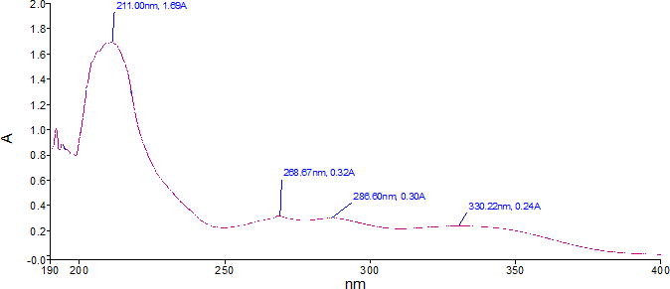

Fig. 3. UV-Vis spectrum of F2a isolates

40.1
1121.74
1463.47
1456.04
2852.52
2924.84
1354.27 1182.03
1652.64 1071.94
1729.25 1269.89
1611.99
3343.91
738.23
828.08

38

36

34

32

30

%T 28
26

24

22

20

18

16.0
4000.0 3000 2000 1500 1000 450 .0
cm-1

Fig. 4. FTIR spectrum of F2aisolates

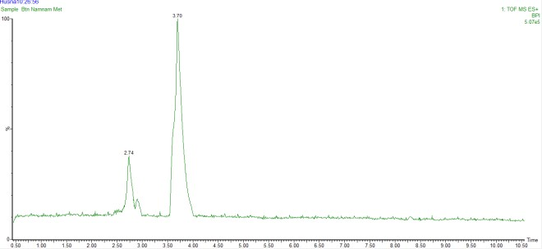

Fig. 5. LCMS chromatogram ofF2a isolate
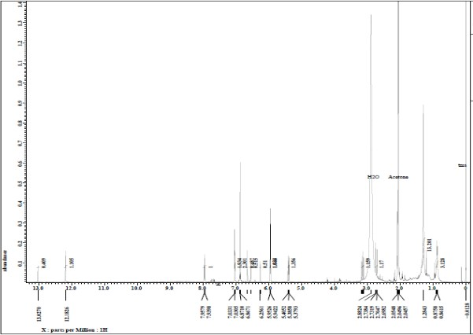

Fig. 6. ¹H-NMR spectrum ofF2a isolate

FT-IR data (Table 3) demonstrated that the isolate F2a were hydroxyl, carboxyl group, C- O group of compounds containing alcohols, ethers, esters and carboxylic acids, the group C=C alkenes and alkane groups.

Table 3. Cluster analysis functions the FTIR spectrum isolates F2a

No | Wave number (cm⁻¹) | Intensity | Interpretation
1 | 3343.91 | Moderate | Streching O−H
2 | 1729.23 | Sharp | Streching C=O
3 | 1652.64 and  1611.99 | Moderate | Streching an C=C
4 | 1269.89 | Sharp | Streching C−O
5 | 828.08 | Sharpes | Bending C−H (para)
6 | 738.23 | Sharp | Bending C−H (orto)

The LCMS results yielded two chromatographic peak spectrums (Figure 5) with retention times (Rt) of 3.70 and 2.74 minutes with a molecular weight of270.9246 and 288.9193, respectively. Peak at a retention time of 3.70 with a molecular weight of 270.9246 g/mol is the culmination of the most dominant compared to the retention time of
2.74. Based on these results, F2a flavonoid was characterized as a compound with the molecular formula of C₁₅H₁₀O₅, same as 4 ', 5,7-trihydroxyflavone that was known as apigenin [18]. The structure of the apigenin can be seen in Figure 7.

OH
O

HO

OH O

Fig. 7. Stucture of apigenin

The flavonoid at a retention time of 2.74 with a molecular weight of 288.9193 g/mol was determined as a compound with the molecular formula of C₁₅H₁₂O₆, similar to that of (2S)-2-(3,4-dihydroxyphenyl) -5, 7- dihydroxy-4-chromanone otherwise known as eriodictyol [19]. The structure of the compound apigenin can be seen in Figure 8.

OH
O

OH

HO

OH O

Fig. 8. Structure of eriodictyol

The peaks of the chemical shifts of ¹H- NMR spectrum (Figure 6) still overlapped because F2a was not pure isolates, however, it could be explained that the ¹H-NMR spectrum showed that there are seven proton regions δ_{H}
5.95 to 7.03 ppm. 1H-NMR (acetone-d6) showed at δ_{H} 5.95 ppm (1H, d, J = 1.95 Hz); 6.25 ppm (1H, d, J = 1.95 Hz); 7.03 ppm (2H, d, J = 7.87 Hz); 6.87 ppm (2H, d, J = 7.87 Hz) and 12.18 ppm (1H, s). The signal at δ_{H} 5.95 ppm (1H, d, J = 1.95 Hz) and 6.25 ppm (1H, d, J = 1.95 Hz) indicated meta pairing on the aromatic ring and at δ_{H}
7.03 ppm (2H, d, J = 7.87 Hz) and 6.87 ppm (2H, d, J = 7.87 Hz) indicating ortho pairing of the aromatic ring to another and symmetric. The signal at δ_{H} area of 12.18 ppm (1H, s) demonstrated the presence of hydroxyl groups form hydrogen bonds with the oxygen of the carbonyl group.
1H-NMR spectrum analysis of F2a isolate provided general information that the isolate was flavonoidas apigenin compound that was suspected because of its aromatic proton signals in the area to be exact. There were two aromatic rings substituted in the framework structure isolate F2a. Table 4 showed the ¹H- NMR chemical shifts of isolate F2a. Isolated apigenin had a very strong antioxidant activity (IC₅₀ 5.18 ± 0.014 ppm).

Table 4. ¹H-NMR spectra data of F2a isolate

C-  position | δ_{H} ( ∑H, Multiplisity, J= Hz) | Alleged Sructure
2 | − | −
3 | 6.86 (1H, s) | HC=C
4 | − | −
5 | − | −
6 | 5.95 (1H, d, 1.95) | HC=C
7 | − | −
8 | 6.25 (1H, d, 1.95) | HC=C
1’ | − | −
2’ and 6’ | 7.03 (2H, d, 7.87) | HC=C
3’ and 5’ | 6.87 (2H, d, 7.87) | HC=C
4’ | − | −
5 | 12.18 (1H, s) | – OH

The molecular structure of compounds F2a isolates were determined based on the analysis

of UV-Vis spectrum ((λmax) 268.767 and
330.22 nm), FTIR (Table 3), LCMS (m/z 270.9246) and data ¹H-NMR (Table 4) allegedly had two and a cyclic aryl which was the hallmark of flavonoid skeleton, one double bond C=O and one double bond, so that F2a isolate was identified as 4 ', 5,7-trihydroxy- flavone or better known as apigenin with the molecular formula C₁₅H₁₀O₅ (Figure 9).

6.87
(2H, d, J= 7.87 Hz)
H
Flavonoid pada Enam Tanaman. Bogor: Institut Pertanian Bogor.
[4]. Kristanti, A.N. Nanik, S.A. Mulyadi, T. Yusamsutin, A. dan Dahlia, S.M. 2006. Isolasi Senyawa Antrakuinon dari Cassia multijuga (Leguminosae). Jurnal Kimia Indonesia. 1(1): 17-21.
[5]. Syahri, J. Rullah, K. Siregar, S.H. 2012. Bioaktivitas Ekstrak Kulit Batang Tumbuhan Langka Meranti Lilin (Shorea teysmaniana DIER). Jurnal Photon. 3(1):1-6.

6.25
(1H, d, J= 1.95 Hz)

H
HO ⁸

7.03
(2H, d, J= 7.87 Hz)
H
2'

O 1'

3' OH
4'
[6]. Dai, J.R. Hallock, Y.F. Cardellina, J.H. Boyd, M.R. 1998. HIV-Inhibitory and Cytotoxic Oligostilbenoids Isolated from
The Leaves of Hopea Malibato. J. Nat.

7 9 2

6
5'
6' H 6.87
(2H, d, J= 7.87 Hz)
Prod. 61: 351-353.
[7]. Geewananda, Y.A. Gunawardena, P.

10 4
H 5
3 H7.03
H (2H, d, J= 7.87 Hz)
Sotheeswaran, S. Sultanbawa, M.U.S.

5.95
(1H, d, J= 1.95 Hz)
OH O
12.18 (1H, s)
6.86 (1H, s)
Surendrakumar, S. Bladon, P. 1986. Another antibacterial polyphenol,

Fig. 9. Structure and Chemical shift of F2a isolates

CONCLUSION
Based on this study, it can be concluded that the ethyl acetate extract of namnam heartwood have antioxidant activity with IC₅₀ value of 4.68±0.035 ppm. Based on the analysis of UV-Vis, FTIR, LCMS and ¹H- NMR, structure of the active antioxidant compounds with IC₅₀ value of 5.18 0,014 ppm from isolate F2a was identified as 4', 5,7- trihydroxy-flavone or apigenin with molecular formula C₁₅H₁₀O₅.

REFERENCES
[1]. Soeharto, I. 2001. Pencegahan dan Penyembuhan Penyakit Jantung Koroner. Jakarta: PT. Gramedia Pustaka Utama.
[2]. Winarsi, H. 2007. Antioksidan Alami dan Radikal Bebas: Potensi dan Aplikasinya dalam Kesehatan. Yogyakarta: Penerbit Kanisius.
[3]. Widyastuti, N. 2010. Pengukuran Aktivitas Antioksidan dengan Metode Cuprac, DPPH, dan Frap serta Korelasinya dengan Fenol dan
coppaliferol B, from Vaterian copallifera (Dipterocarpaceae). Phytochemistry. 25: 1498-1500.
[8]. Aziz, A.F. dan Iqbal, M. 2013. Antioxidant Activity and Phytochemical Composition of Cynometra cauliflora. J. of Exp. and Integr. Medicine. 3(4): 337- 341.
[9]. Sukandar, D. Amelia, E.R. 2013. Karakterisasi Senyawa Aktif Antioksidan dan Antibakteri dalam Ekstrak Etanol Buah Namnam (Cynometra Cauliflora L.). Jurnal Valensi. 3(1): 35-40.
[10]. Rabeta, M.S. and Faraniza, N.R. 2013. Total Phenolic Content and Ferric Reducing Antioxidant Power of The Leaves and Fruits of Garcinia atrovirdis and Cynometra cauliflora. International Food Research. 20(4):1691-1696.
[11]. Tajudin, S.A. Mat, N. Bakar, A. Yusra,
A.M. Alwi, A. Ali, A.M. 2012. Cytotoxicity, Antiproliferative Effects, and Apoptosis Induction of Methanolic Extract of Cynometra cauliflora Linn. Whole Fruit on Human Promyelocytic Leukimia HL-60 Cells. Hindawi Publishing Corporation-Evidence-Based Complementary and Alternative Medicine. 2012:1-6.

[12]. | Molyneux, P. 2004. The use of the stable free radikal diphenylpicrylhydrazyl (DPPH) for estimating antioxidant  activity. Journal Science of Technology. | [16]. | vitro Antioxidant Activity of Aconitum anthora L. (Ranunculaceae). Phytochemistry. 69: 1220-1226.  Winarno. 1991. Kimia Pangan dan Gizi.
 | 26 (2): 211-219. |  | Jakarta: PT Gramedia Pustaka Utama.
[13]. | Bouktaib, M. Atmani, A. and Rolando, | [17]. | Markham, K. R. 1988. Cara
 | C. 2002. Regio- and Stereoselective |  | Mengidentifikasi Flavonoid. Bandung:
 | Synthesis of The Major Metabolite of |  | Penerbit ITB.
 | Quercetin, Quercetin-3-O-b-D- | [18]. | Ogihara, Yukio. 2001. Phenolic
 | Glucuronide. Tetrahedron Letters. 43: |  | Compounds from Scutellaria pontica.
 | 6263-6266. |  | Turk J Chem. 26: 581-588.
[14]. | Hollman, PCH and M.B. Katan. 1997. | [19]. | Miyake, Y. Yamamoto, K. and Osawa,
 | Absorption, Metabolism and Health |  | T. 1997. Isolation of Eriocitrin
 | Effects of Dietary Flavonoids in Man. |  | (Eriodictyol 7-rutinoside) from Lemon
 | Biomed. & Pharmacother. 51: 305-310. |  | Fruit (Citrus limon BURM. f.) and Its
[15]. | Mariani, C. Braca, A. Vitalini, S. |  | Antioxidative Activity. Food Sci.
 | Tommasi, N. Visioli, F. and Fico, G. |  | Technol. Int. Tokyo. 3 (1):84-89.
 | 2008. Flavonoid Characterization and in

